Petit Prince Mini-Book Project

Your task: Create a 10-page book that will teach someone else (who has never read Le Petit Prince) the lesson(s) the Little Prince and the Pilot tried to teach you, the reader, in the novel.

- Utilizing your list of quotations and your journal entries, identify what you consider to be the essential lessons from the novel.
- Your book should consist of 10 pages, plus a front and back cover. You are welcome to used colored paper for your covers, but not the pages of text. The diagram below is considered ONE PAGE.

- Each page should contain a quote and the lesson illustrated by that quote. Both should be in French and in English.
- If a picture is needed, you should add one.
- I expect a minimum of five (5) illustrations and ten (10) quotes/lessons inside your book. Cover art does not count as any part of your 5 required illustrations.
- You may hand-write or type your text, and you may draw your pictures or use clipart, but everything needs to be harmonious—it should all be there to further your idea.
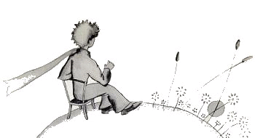
- The last “page” of your book (not part of the 10 pages) needs to list the source of each quotation. In order to cite your source, please list the chapter number, page number, and line number of your quote. For simplification of the citations, please find your quote in the version of the text we used in class. You may borrow one of my copies in class to locate these if you used a different version while we were reading.

Questions? See me!

Due: Thursday, October 26

